 Version 1

Advisor’s Ally
…your partner for success!

Practice Management Software for Fee-Based Advisors

Quick Start Guide
Demonstration and Use
Get going in 5 minutes or less!
Note: There is an additional User Manual Document located on the CD!

The most popular and most complete software for advisors, financial planners, brokers and their teams is the perfect tool to help you Find, Retain and Profit from the best clients!

SCHERRER RESOURCES, INC.
Investment Advisor Software
120 Arrandale Boulevard, Exton, PA 19341-0207
Or, e-mail: Sales@AdvisorsAlly.com, Or, Support@AdvisorsAlly.com
25 Years of Investment Management Software 484-875-1710-sales, 484-875-1705-support
Advisor’s Ally Quick Start Guide and Demonstration

Table Of Contents
Introduction: What To Expect From the Advisor’s Ally
Getting Started: How To Install Your Disks
Advisor’s Ally Test Drive: Adding, Finding and Scheduling Your Contacts and Activities
Interest Classes, Categorization, User Defined Fields: Profiling your contacts
Portfolio Holdings, Trades, Transactions: Posting Trades, Creating Reports, Asset Allocation
Reports and Other Output: Searching the database and Sorting the output
Letter Writing Word Processor: Correspondence, Group Mailing, Marked Letters
Special Tools: Help Menu, Tip of the Day, What’s New, Market Data Pricing
Networking Computers Together: Working together as a team with one database
The People Behind the Product: Scherrer Resources Help Desk, Training and Installation
----------------------------

INTRODUCTION

What to expect from this Quick Start Guide and Demonstration Manual
Congratulations on taking the first step towards translating today’s computer technology into increased efficiency and real monetary gain! Advisor’s Ally makes use of all of the advantages of the modern computing environment to give you the power to execute your own sales strategies. You will find that the newest version of Advisor’s Ally is a powerful and dependable tool for maximizing your time, tracking your clients and increasing your earnings. We hope the time spent with this Quick Start Guide will help you make use of this exciting technology to realize your full potential as an advisor, financial planner or their assistant.
The purpose of the Quick Start Guide is to show you the wide range of Advisor’s Ally functions and how easy they are to use, to help you install quickly and get going fast. Quick answers to questions are in the software itself, under the Help menu item. Answers to remaining questions can be gained by calling your Advisor’s Ally Help Desk Technician at 484-875-1705, by reading the User Manual file located on your CD, by viewing AdvisorsAlly.com, or e-mail to Support@AdvisorsAlly.com.

How to install CD on Windows 95/98/NT/XP/Win7/8 etc. for Advisor’s Ally v1

Insert the CD in the drive and it will install itself, if not, read this:
- Select Start, located in the lower left hand corner of your screen.
- Choose Run from the file menu.
- Put distribution CD into drive A or B.
- Type A:\SETUP or B:\SETUP in the run dialog box and click OK.
- The installation program will install Advisor’s Ally into a default directory, example C:\AA1.
- Follow the instructions as they appear on your screen.
- Now you have a new window within your Program Manager titled “Advisor’s Ally 1.0”.
- The Set-up Installation is now complete. Now double click on the Advisor’s Ally icon.
Network Installation- After you establish the server PC, you must install Advisor’s Ally on each workstation PC. From each workstation PC, you must map to a network drive; once you establish the network drive, you must edit the bawin8.ini file that is located in the C:\Windows directory, or C:\Win NT directory. There is a [ DATA ] section in the .ini file, under the [ DATA ] section, there is a dsF1 command line, that has to point to the network drive and directory where your data is located. Example: dsF1=F:\aa1\main.dbf.
You are now ready to start using the newest Advisor’s Ally!

Advisor’s Ally

Features of Advisor’s Ally

Advisor’s Ally was designed to include a complete product encompassing 3 “building blocks” or “components” of functionality.

Basic features you have come to know as “the classic” Advisor’s Ally CRM platform.
Perfect for complete office database needs.
Track clients, prospects, and leads; notes of conversations
Monthly, weekly and daily calendars
Integrated word processor with built in spelling checker, e-mail and more
Post stock, bond, and other financial products & print standard reports
Menus, button bars, drag & drop, tool bars for ease of use

Marketing features such as CSV/ASCII data loading utility and extra power tools for a Marketing Powerhouse.
Designed for the more robust needs of advisors and planners wanting to have special prospect databases or to create specialized sales plans and campaigns. This level is especially helpful for team assistants. Load databases of prospects. Sales Planner for scheduling multiple calls, actions and meetings for prospects and clients. Over 20 built in sales letters, fee-based contracts and over 100 sales scripts.

Portfolio and holdings functions for portfolio management oriented advisors. Designed for the more demanding needs of advisors with large and diverse portfolios, financial planners and money managers.
Asset Allocation Reporting, assign security types to asset classes
Reporting for Clients, good-looking reports to distribute to clients
Reporting for Advisors, in-house reports to assess your production and business style
Campaign Planner, to expedite investment campaigns
Portfolio value rank reports and Positions rank reports
Stock pricing download connections

Included Service:
We offer our premium service for heavy duty, professional users of Advisor’s Ally. It includes telephone hotline access, our Ally Newsletter, fax back and e-mail support, and up to 2 free software upgrades (2 shipments/yr). This software shipment insures you are up to date at all times. No other upgrade fees are charged.

Training Services Offered: Designed for those who wish help in learning all the full feature set. Telephone Training Services by appointment. Or, on-site Training Services by appointment.
ADVISOR’S ALLY QUICK START GUIDE and DEMONSTRATION MANUAL
There are many ways that the new Advisor’s Ally will make your workday more efficient and this QUICK START GUIDE will discuss a sampling of the many features that are built into Advisor’s Ally to manage a wide range of advisor activities. After installing the program, your first order of business is to enter data into the Advisor’s Ally database; which will be an ongoing process. To get familiar with the contact screen, the Advisor’s Ally demo database both allows you to add your own records and to view actual clients that you add into the software.

Add Your Contacts to the Database
The first thing that you need to do with your Advisor’s Ally is to add your client and prospects to the database. There are two steps to input a contact.
To add a contact
- Use your mouse to click on View at the top of the Advisor’s Ally window and select Add Contact.
- Enter your contact’s name, address and phone and fax numbers. Use your Tab key to quickly move between the different fields in the contact screen. Use the mouse to select entries from drop down boxes. Then Save!
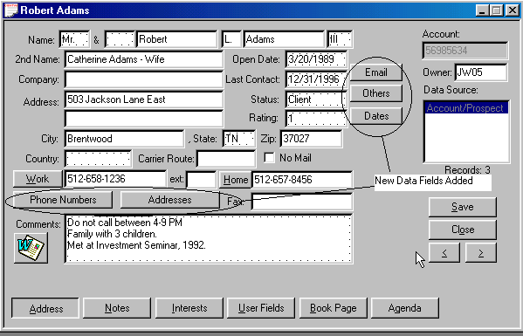
Main Contact Page- New Fields for e-mail, contacts, important dates & addresses
The Client Contact Screen

Find A Contact in Your Database
- Select View from the menu at the top of your Advisor’s Ally screen.
- Click on Find Contact from the pop down menu.
- Enter your desired fields into the Find Contact screen.
(For example, you would enter "Johnson" into the last name field and "UT" into the state field
to find all of the Johnson’s who live in Utah)
- Use your mouse to click on the Find button. This contact record will then be displayed from your datasource.

Schedule Your Contacts for a Call, Action or Meeting
As you add new contacts to your database, you should add a date (and possibly a time) to execute a call, action or meeting with that person. This way, nobody in your database is forgotten. For example, assume one of your best clients has given you a great referral. After you add this contact’s record into your computer, you decide to schedule a time to give the referral a call to set up a meeting. In Advisor’s Ally, we call these various appointments Activity dates. Generally, there are three major types of Activities; Calls, Actions or Meetings. Instead of struggling to remember them yourself, let Advisor’s Ally do it for you.
To Schedule an Activity with a Client
- First, you must have that persons contact record on your screen. Then, use your mouse to click on the Agenda Button at the bottom right of the contact record. From here you see all the calls, actions, or meetings you currently have scheduled with this single contact.
- Add a new activity by selecting the Add Button. Then flesh out a full Description of your activity into the Schedule Activity box such as “Introductory Call” then Select Type of Activity as Call, Action or Meeting, set the correct date and time, and then...
- Click on Add to Add this Activity both to your Activity Calendar and this contacts’ Agenda.
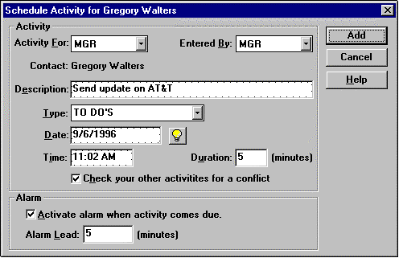

Working With Your Activities Calendar
The Activities Calendar of Calls, Actions & Meetings:
Now that you have added your contacts to your database and have scheduled them for some type of activity, Advisor’s Ally will begin its job of making your day more efficient and organized. The first thing that you should explore is your Activities Calendar. You can view your Activities in a daily, weekly or monthly format through the Activities Calendar.

To view the Activities Calendar
- Use your mouse to click on View.
- Select Activities Calendar, which has arranged all your Calls, Actions and Meetings for you.
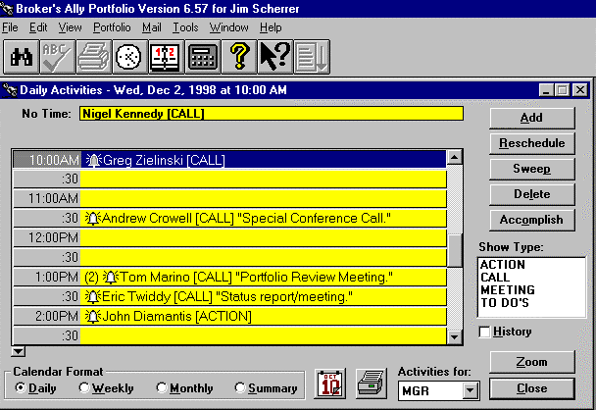
View and execute your Calls, Actions or Meetings from the Activities Calendar

Summary View ... or the Daily, Weekly or Monthly Format of the Activities Calendar
You are able to switch between your daily, weekly and monthly schedule formats by clicking on the circular buttons at the bottom of the screen. Choose the Summary format if you wish to view all your activities in a single list at one glance. If you wish to view an event in greater detail, use your mouse to first click on that contact activity then push the Ally Zoom button in the lower left corner to bring you to the next level of detail. For example, if you are looking at your Daily schedule and want to view a contact on it in more detail, simply click on the contact activity, press the Zoom to view this contact. By using the Zoom feature, you can use the Activities Calendar as the main working screen of Advisor’s Ally.

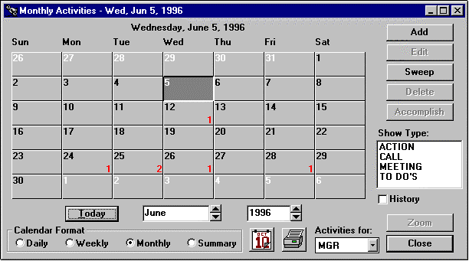
To get more details of your schedule, choose Daily, Weekly, Monthly, or Summary view.

1) Click on the listing of the activity listed on the Activities Calendar screen.
2) Hit the Zoom button, or “double click” on the contact name, to display the contact’s record.
3) After “zooming” in on the contact’s record, you have all the information in front of you that you need to execute the scheduled event.

Use Your
Activities Calendar
Every Day!

Nothing Falls Through the Cracks!

The Daily View
This process will create a list of people for which you have activities for today’s date. You can select them by double clicking with your mouse, or selecting Zoom. Now you may carry out your activity, for example, making a call. After you finish with this contact, move to the next contact person by using your mouse to press the Close Button, and selecting another contact record as above. You will want to Edit the Activity Dates, if you need to reschedule an activity not yet completed.
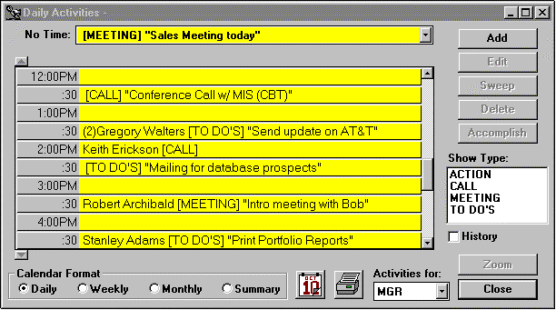
Viewing your Activities Calendar in “Daily View”

For more clarity, you might, for example, wish to see only the Calls scheduled for today. In this case you would click on the Call type in the Show Type box at the right of the screen. Or, you might wish only to view Actions ... then click on only the Action in the Show Type box. In this way you can see all Activities, or only those of a specific type for a specified day.

Historical View
Note on the screen a small box labeled “History”. If you click on this (make an “X”), you will see displayed all your historical activities that have already been accomplished. These historic activities are entered here by the “Accomplished” Button and are cataloged in the order the activities were accomplished.

Advisor’s Ally can help boost sales productivity by tracking prospects faster, giving better client service, quickly tracking stocks, bonds and other financial product purchases, targeting money “coming due”, homing in on future business potential, staying organized, making quick phone lists, and coordinating the efforts of assistants to give you the power to run an integrated support team!

Send Your Contacts The Information that they Request- The power of the Notepad
In the notepad, you can type in notes contemporaneous with the conversation that are date and time stamped. Further, after a phone conversation or a meeting, customers may request follow-up information. You then “mark” a note as a “to-do” thus ensuring the correct information is sent. You print these marked notes onto mailing labels at days end by selecting Print Label, then Marked Notes from the Mail main menu.
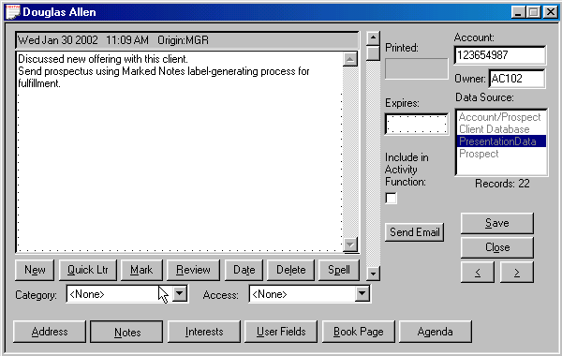
To Mark a note for a contact, select the Notes button, then select Mark

- From the Name and Address screen of the contact’s record, click on the Notes button.
- Type what the contact should be sent, then
- Click on the Mark button.
- At the end of the day, select Mail from the main menu on the top of the Advisor’s Ally screen.
- Select Marked Notes then Labels..
- Select the label size, then Print, then use these printed labels and their associated notes to mail the items.

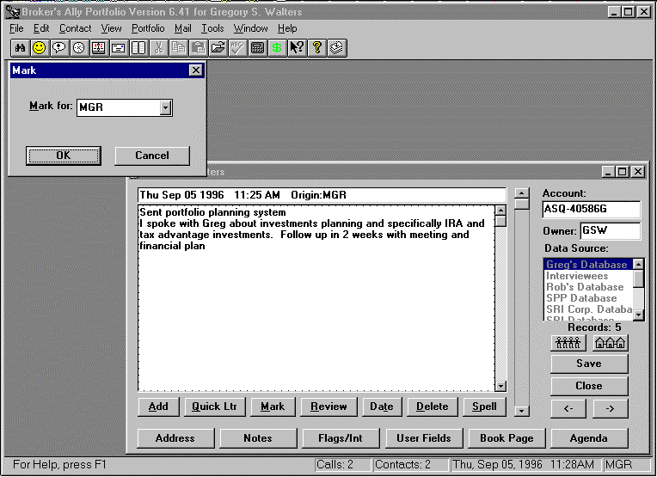
Taking Notes of conversations in the Notepad, then Marking Notes for a to-do list

Sending Marketing Letters & Creating Batch Mailing Labels
The Letter Writer creates sales Letters, while the Reports section creates mailing labels. A large part of any successful advisor’s business is keeping in touch with contacts through the mail. Advisor’s Ally for Windows provides a fully functioning word processor to handle all of your correspondence. This word processor allows you to compose new letters and work with old ones. You can use the Letter Writer to send an individual letter to a client, or to send letters to groups of your contacts. You can use window envelopes to send these newly created letters or you can create mailing labels in the View, Reports Section. You can create batches of mailing labels in Reports, labels, Print, then select the list. Read more about these things under Letter Writer and Reports in this Quick Start Guide.

Keep Track Of Your Progress
It is important to know how well you are calling and selling. The Phone Tallies is a Standard report that provides you with an instant view of your progress on a weekly, monthly or yearly basis. This report will allow you to track the number of calls that you have made and the people that you have been able to reach with percent % success. You can track your progress over time by viewing or printing your totals for the previous months or years. In network situations, you are able to evaluate another user’s call progress by viewing their tallies information. This is useful for advisors who have their assistants do their telemarketing or for managers of a group of advisors.
The Phone Tallies Report gives you the opportunity to set goals and track your progress towards them. For example, you might give yourself a goal to contact 50 people a day and 100 new prospects per month. After working towards this goal, you can check your tallies. If your tallies report shows that you have exceeded your goals, then you might possibly want to adjust your goals higher.

To Create a Tallies Report:
- Select View from the main menu at the top of the Advisor’s Ally for Windows screen, and select Reports.
- In the Reports dialog box, select Standard.
- Use your mouse to select Phone Tallies from the box below the words “Available Reports:”
- If you would like to preview the report, hit Preview. If you would like to print the report, select Print.

INTEREST CLASSES AND CATEGORIES
Advisor’s Ally allows you to track the INTEREST classes of your clients and prospects. You can set up your own Interest classification scheme under Edit, User Preferences. You can set up 28 Interest categories that define the conceptual meaning of these Interest classes. Further, you can categorize your clients and prospects using FLAGS as depicted in the window on the right side of the screen in the Interest section. FLAGS are database-sorting handles that you can assign to contact records in your database for quick access in sorting, using words such as “Tennis, Golf, etc.” STATUS, which is found on the Address Page, defines where they stand in the sales cycle, starting with Lead, moving to Prospect, then ending, hopefully, as a satisfied Client. RATING defines how “hot” the prospects and clients are in your database in a numeric scale from 1 to 10 with 10 being the “hottest”. A STATUS=Prospect, with a RATING=10 should soon become a Client Status through your sales efforts.

USER FIELDS
You, the “user” can create your own “User Defined Fields” in Advisor’s Ally to track other information you feel pertinent to your business. Examples of field names you might define are: Net Worth, Income, Secretary, etc.. You can define up to 48 user-defined fields in Edit Menu under User Preferences. Then, after setting up the headings to these fields you can enter data into the field blanks to track pertinent information about your clients and prospects. You can also define the type of information stored in these fields, for example date fields, numeric fields, and text fields.

User Fields, Interests, Flags and Status are very useful for retrieving a special group of records from your database of contacts. You can print reports or mailing labels for people having specific FLAGs and/or Classes, or group them for calling, generating reports, or printing letters.

POSTING BOOK- “Post” your transactions...
The posting book is selected by clicking on the “Book Page” tab. From here you can view, add or subtract entries in the portfolio book page. You can open new positions or close old ones.

Up or Down Positions- Advisor’s Ally for Windows now has a graphical posting book that indicates, at-a-glance, whether a position is up or down in relation to the market price. A green up-arrow indicates a current gain, while a downward red arrow indicates the position is down from the original open price.
Aggregate Value At A Glance- The bottom of the screen shows a compilation of value across all positions. This includes the total open cost, total market value, and Gain or Loss on the portfolio as of the current day.
Color Screen- The use of color on the screen helps the viewer to quickly observe different regions of the screen. Blue, red and black numbers also provide information to indicate relative value of the holdings. The person whose portfolio is being viewed is shown within the top screen Title Bar.
Open, Close and Remove Positions- Now you can open, close, or remove positions by clicking on the selection buttons at the bottom of the screen. These actions are immediately reflected in the on-screen calculations within the posting book.

Portfolio Features

This section describes features of the Portfolio
- General Ledger- View the holdings general ledger, cash ledger and the ability to track both transactions and positions and to manage alternative accounting methods such as LIFO, FIFO and average cost.
- Securities Descriptors- View the CUSIP number and the Description extensions of securities. This corresponds to the Interactive Data Corporation format; FT IDC format.

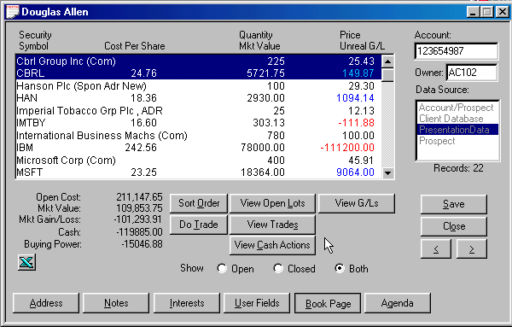
Security Transaction Ledger and Cash Transaction Ledger

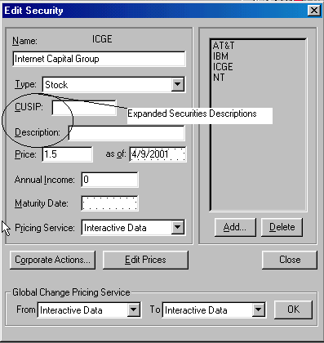
CUSIP and Descriptor Fields Added

- Sorting Flexibility- Created multiple screen display sorting methods including sorting by description, quantity, price, market value, and gain or loss, in either ascending or descending numeric or alphabetic order for ease of reading and viewing.

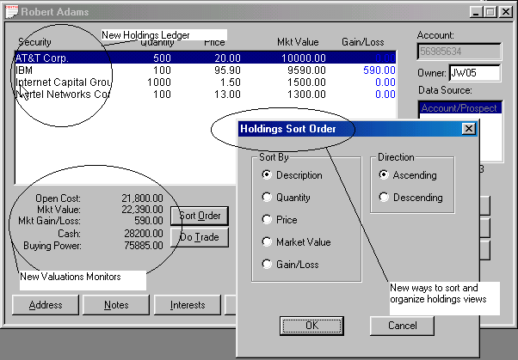
Holdings Ledger- New Sort Order- Expansion all functionality

- Cash Accounting- View the cash balance ledger and accounting functions for debit and credit to cash accounts.
- Connectivity to Clearing Firms- We’ve created data loading utilities to load data from the following back office services with their support: Raymond James, Beta Systems, Pershing, Fiserv, US Clearing, CheckFree APL, TD Waterhouse, Sungard Phase3, and FT Interactive Data Corp for end-of-day market pricing of portfolio.
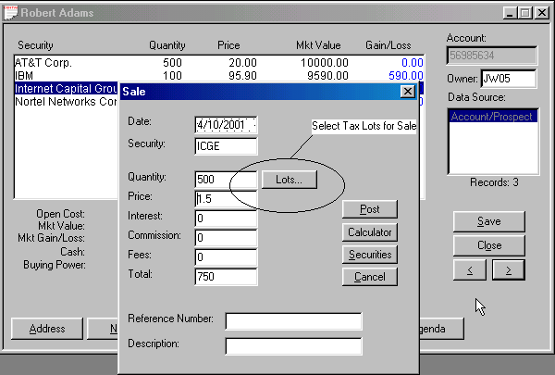
Tax Lot Selection for Sales

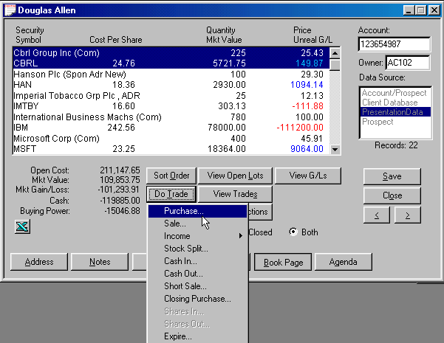
Screens to Support Trade Methods

Post All Your Transactions!

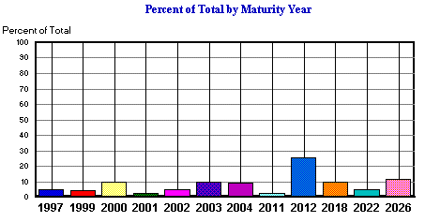
Export to Excel and print graphs of portfolio information.

THE PORTFOLIO SYSTEM - More power for business building!
The Advisor’s Ally Portfolio Level is additional functionality for enhanced reporting, depicting asset allocation, and initiating investment sales campaigns. It prints or displays client or advisor reports, calculates asset percentages and shows future income and bond payouts. Included here is an outline of the features of this Portfolio Manager. Its main functions are listed under the menu item "Portfolio" at the top center of the screen, shown below.

Portfolio Level: The Pull-Down Menu
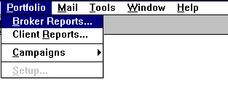
Portfolio management functions for your business:
Portfolio Reports- These reports allow you to generate reports based on your postings and is divided into two types of reports: client reports and advisor reports.
Client Reports- Realized and unrealized gain and loss, portfolio value based on asset classification, bond maturity and many other reports can be generated. These reports are created using transaction information listed in the posting book and mating against the securities master files.
Advisor Reports- These reports are usually in-house reports to assist advisors and sales assistants in assessing business performance. Reports included are commission reports, large position holdings, portfolio rank reports, transaction listings by date, securities by symbol and type.
Asset Classification- Allows you to define an unlimited number of asset classes, assign security types to them, and then print client and advisor reports based on them.
Investment Campaigns- Investment and Sales campaigns keyed on a specific financial product, portfolio holdings and asset classes, such as tax-advantaged investments, large portfolios, and maturing bonds.
Post- Automatically downloads your transactions and pricing based on in-house connections.
Only available where your firm supports automated transaction and security master file database loading.
Re-Organizations of Securities-Reorganized positions based on holding changes: splits, sales & purchases.

Example of Client Portfolio Report: Portfolio Valuation Summary- With Pie Chart

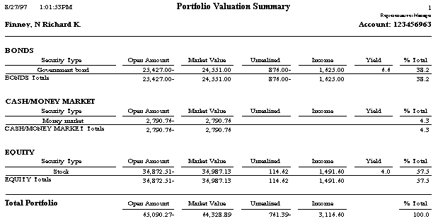
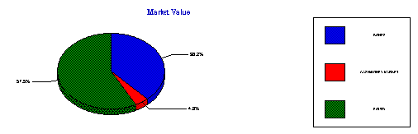

Advisor Report: Transaction Schedule- A Display of all Transactions on a Daily Basis

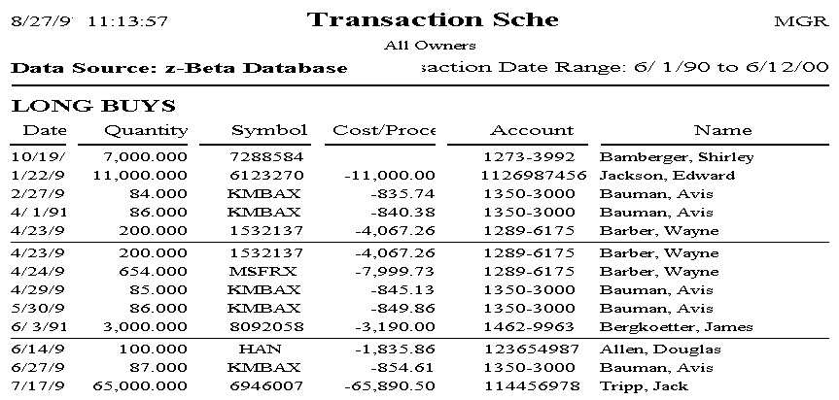

Client Report: Bond Maturity Distribution- Maturity year of bonds, client-by-client basis.
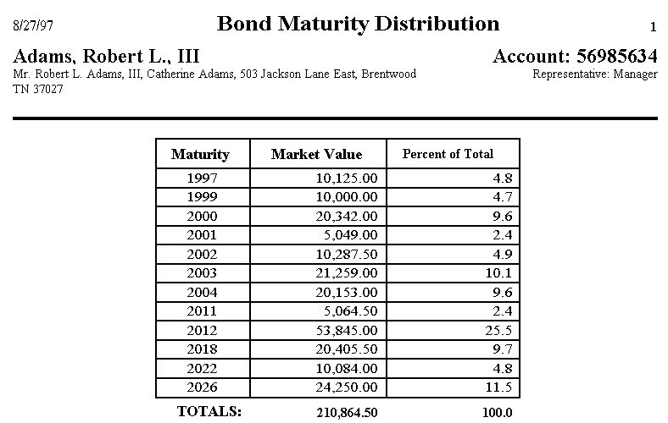

Advisor Report: Large Positions Report-Assets Under Management, ranked by value

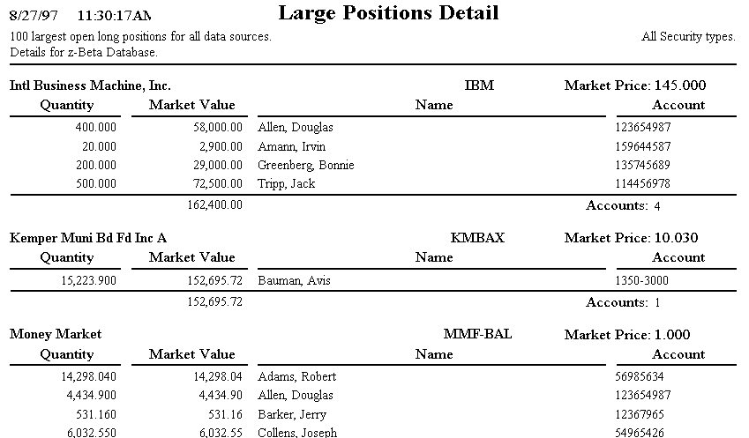

REPORTING- Standard, Labels, Posting and Portfolio Reports
Advisor’s Ally for Windows has a wide range of commonly used report formats using data in its database. The software comes complete with a collection of pre-made report formats, called “Standard” reports. They allow the user to create their own report formats through the Custom Report Generator add on module. These customized reports enable the user to design and create very specialized reporting output.

To Generate a Standard Report:
- Select View from the main menu at the top of the Advisor’s Ally for Windows screen
- Select Campaigns, Group List
- At the next dialogue box, click on the New List button
- Type in a Name to represent the list you are about to create. The name should describe the list, e.g. NameList.
- By using one of the Advisor’s Ally pre-defined templates, you can quickly select a group of contact records.

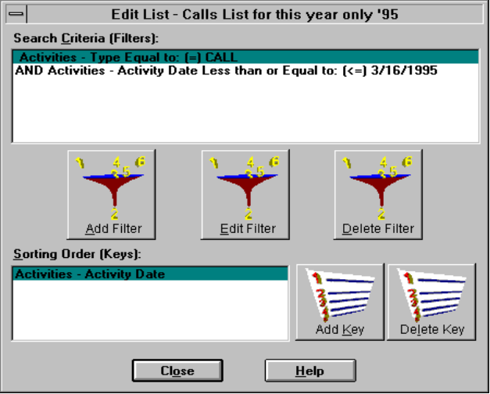
- Once you have selected a template, you will be presented with the Edit List dialog window.
- You can change the search or sort criteria if you desire by clicking on the Edit Filter or Add Key buttons.
- Use your mouse to click the Close button at the bottom center of the screen to except settings you have chosen.
- Now you are ready to print the report based on the list you just created; click OK on List Results.
- Press the View List Button, then click on the Reports button.
- Select the Report you wish to print for these contact, and click on the Print or Preview button

Standard Report Examples
Account/ Company Lists Activities Report
Activities/Phone (Landscape) Report Address/Phone Card Lists
Birthday Report Company/Status
Contact Work Sheet Contact/Notes List
History Last Contact Date/Open Date/Status
Marked Notes Lists Phone Lists
Phone Tallies Report Posting Book Lists
Rating/Status Lists Realized Gail/Loss Lists
Securities Lists Source Lists
State/Zip Lists Unrealized Gain/Loss Reports,
and many more!

Always refer to the www.AdvisorsAlly.com Web Site Portal!

You will find a wealth of information at your fingertips at the expanded www.AdvisorsAlly.com portal for investment professionals. Topics addressed there include market data sources, market commentary, world news, IPO’s, research, US and Global exchanges, business practice improvement tools, trade associations, regulatory bodies, lists of advisor/dealers, clearing firms, education and training support.
LETTER WRITER WORD PROCESSOR

1. Marked Letters
The purpose of the Letter Writer is to help you quickly create business correspondence. There are two ways to use the automatic name and address merge capabilities of the letter writer. The first way is to use the Letter Writer to “mark” a contact for an automatic letter as we shall describe here; many different letters for many different people. Let’s say that you have already written a sales letter with personalized merge codes about a certain mutual fund. During the course of the day, a contact expresses an interest in this mutual fund. Since you have already written this letter, you could “mark” this contact to receive this letter. After you “mark” the contact for a letter, you forget about it until the end of the day at which time you print out a batch of all the letters that you have “marked”. The computer will personalize the letters with the contact's merged data and print them out.

To mark a contact to receive a letter:
- With the contact’s record active on the screen, click on the Contact menu item at the top of the Advisor’s Ally for Windows screen.
- Select Mark a Letter.
- At the Marked Letters For____ dialog box, hit the Add button.
- Use your mouse to select the letter.
- Then Click the OK button to Close the Dialog Box window.

Now- How to print marked letters?! Read on...
- Select Mail from the top of the Advisor’s Ally for Windows screen.
- Select Marked Letters from the drop down menu.
- Select the Letters button underneath the word Print.
- When the marked letters are printed you will want to Delete All the markings on the contacts so they won’t come out again the next time you print marked letters.

2. Group Mailing or Group Emailing
The second way to make use of the Letter Writer’s automatic merge capability is to create a Group Mailing, many people getting the same letter. You can use a Group Mailing to create a large group of personalized letters to a select group of contacts in your database. For example, if you wanted to create a personalized marketing letter about a new retirement fund for all of you contacts that were self employed, you would make use of the Group Mailing.

To create a Group Mailing:
- Select Mail from the top of the Advisors Ally for Windows screen
- Select Group Letter from the drop down menu
- At the next dialogue box, click on the New List button.
- Type in any name for the search that you are about to do. The name should describe your list, e.g. NameList
- By using one of the Advisor’s Ally pre-defined templates, you can quickly select a group of contact records.
- Once you have selected a template, you will be presented with the Edit List dialog window.
- You can change the search or sort criteria if you desire by clicking on the Edit Filter or Add Key buttons.
- Use your mouse to click the Close button at the bottom center of the screen to except settings you have chosen.
- Press the View list button, Then Mail Merge!
- Select the letter to merge, for example BIRTHDAY.BAL. Click on Open
- Now Advisor’s Ally will merge the names and print this list.

Group Email Broadcast
After creating a letter with merge codes for personalization and creating a list of contacts, you can use Email Broadcast to email everyone in the list a personalized email letter.
1) Select to view your list using the View | Campaigns menu.
2) Click Email Broadcast
3) Type in the full path name of the letter file or browse to select it.
4) Type in a subject for the email.
5) Click OK.
Now Advisor’s Ally will immediately merge the letter with each contact and email the personalized letter.

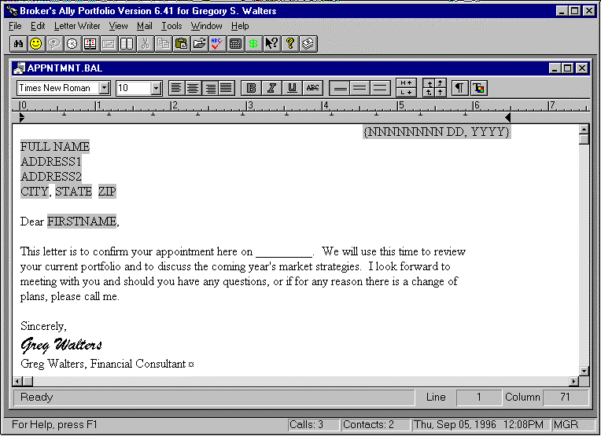
Word-processing with the built-in letter writer, mail merge and spell checker

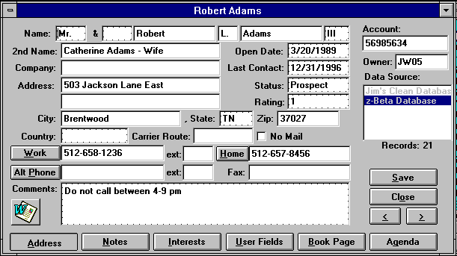
Icon to press to merge name/address information into Word Letter. Excel Spreadsheet Icon available, too.

Benefits of Using Advisor’s Ally
Here are some benefits derived from implementing the Advisor’s Ally productivity, client relationship management (CRM), and portfolio management system for fee-based investment advisors, financial planners, assistants and portfolio managers.

Extend Longevity of Relationship- Capturing detailed client and prospect information will help to secure a positive client relationship for a longer period of time.
Enhance other offerings and cross selling- Use of Advisor’s Ally helps to increase penetration of all products being offered.
Compliance Satisfaction- Supports consistent, targeted and measurable behavior of account representatives and their assistants with note taking and audit trail reporting.
Increase Productivity and Sales Revenue- Helps to support more productivity and efficiency in all daily operations.
Better controlled Teams- Helps ensure all advisors and assistants work in a well-defined path following their strategic plan.
Increase Assets Under Management- Helps uncover hidden assets by using structured data gathering and client profiling.
Open More Accounts- Helps to increase sales pipeline conversions from status of qualified prospect then on to the client status.
Do More Trades- Helps empower reps to “always have a reason to call” by profiling customers and target marketing appropriate products to all clients.
SPECIAL TOOLS- Additional tools to aid your business as shown and described below.
These quick-access Tools make Advisor’s Ally unique to your business.

What’s New: A new Icon in the Advisor’s Ally group tells you about all new features added to Advisor’s Ally.
Tip of the Day helps to teach you new features; one per day ‘till you master the software feature set
Help Files contain a collection of helpful software information. Explore the help file; it’s easy.
Phone Dialer is used to automatically dial the phone using the modem in your PC.
ASCII data loading helps to upload databases from other software into Advisor’s Ally
Built in Sales Letters help you by giving you formats to modify for specialized use.
Sales Planner schedules multiple calls, actions and meeting for clients or prospects.
Stop Watch is a timing device if you are counting time and billing for services provided.
Calculator is a built in calculator to give you a handy access to the computing power of a PC.
Calendar is a date calendar to show you the days of the week and how they fit into the month and year.
Scratch Pad is a handy place to keep general ideas or information not connected to a person.
Sales Scripts are pitches and scripts you and your sales assistant can use to better define a presentation.
Glossary of Financial Terms contains information on a variety of financial product definitions.
IDC Download allows you to subscribe and connect to the IDC pricing service and get end-of-day pricing.


INTERACTIVE DATA FEED for Advisor’s Ally- Subscribe Today!

Interactive Data is the leading provider of global securities pricing and financial data supporting securities operations, fund pricing, portfolio management, and investment research. For 30 years, customers have relied on Interactive Data for value added activities. Interactive Data's extensive and comprehensive coverage includes over 3.1 million securities, and their accuracy, timeliness, reliability, flexible delivery, and unparalleled customer service make the difference between untested raw data and usable information. To order call Financial Times- Interactive Data at: DataFeed Subscriptions, FT Interactive Data, 22 Crosby Drive, Bedford, MA 01730, Tel: 800-432-5463, Fax: 781--687-8613, e-mail: Datafeed@ftid.com. Call now to get set up for fast service.

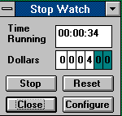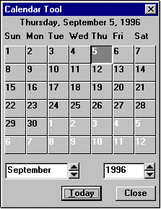
Stop Watch for tracking time and dollars Date Calendar for quick access

NETWORKING TOGETHER- Team Building
Networking several PCs together is the most efficient way for more than one person to simultaneously work with a single group of contacts. The Advisor’s Ally network version software, in conjunction with your existing computer network, ensures that every person working together has quick access to constantly changing client, prospect and portfolio information. Such a system avoids confusion and facilitates accurate information exchange between staff people resulting in a unified, powerful sales workgroup and to ensure all customer contact points share the same customer information and provide consistent and knowledgeable responses. Our unique integration allows all advisors, call center agents, and branch personnel to view and act upon marketing activities and responses. The network version also makes certain that all issues and opportunities are assigned to, and receive follow-up from, the appropriate points of contact. The network version features password protection, user identification access and shared resources. You may add additional users to your system by calling your Advisor’s Ally representative.

 <---Network Connection---->
You can make a “unified sales team” by connecting your assistant and other advisors together on a network

THE PEOPLE BEHIND THE PRODUCT
With Advisor’s Ally, customer service isn’t just the software’s built-in ease of use or the comprehensive Help System. It really begins with people... a full staff of sales and support people, backed by a corporate programming and administrative staff. You’re not just buying a software program; you’re buying the support of our entire company! Call 484-875-1705 or e-mail Support@AdvisorsAlly.com or fax to 484-875-1704, or 484-875-1710.

Software Support Policy
Scherrer Resources, Inc. is committed to providing timely and effective support for its clients. This is accomplished by the assignment of experienced software product representatives and customer support technicians. Product telephone support is available from your sales representative and the help desk by telephone from 9:00 AM to 6:00 PM Eastern Standard time Monday through Friday except for national holidays. Telephone support is FREE after purchase at 484-875-1705.

Support:
The premium Advisor’s Ally support service includes up to two free shipments per year of our then current version, plus Ally Newsletter, 800 phone line access and priority 24 hour fax back service. There is no cost to this as it is part of the licensee payment.

Our Corporate Team is Ready to Support You!
Scherrer Resources, Inc. is a Pennsylvania corporation (www.ScherrerResources.com) and our team is led by CEO founder Jim Scherrer, and includes application software developers, web masters, help desk technicians, analysts, and account representatives assigned to each of our licensees. Help Desk Technician can be reached at 484-875-1705, or fax us at 484-875-1704, or contact Support@AdvisorsAlly.com.

Telephone Training Services 
One-on-One Software Training Services for Our Customers by appointment

PRODUCTIVITY IMPROVEMENT
Personal computers can increase your productivity and organization. However, if you fail to adequately learn important software features you might be frustrated, resulting in a total rejection of your PC.

SOFTWARE TRAINING BY TELEPHONE
In order to help avoid this rejection, Scherrer Resources, Inc. has developed a Telephone Training Service whereby you can obtain software training at the comfort of your desk on your own telephone. By making an appointment with a knowledgeable training representative you can learn the proper use of Advisor’s Ally and how to run it on your hardware.

OBJECTIVES
The objective is to raise your productivity by increasing your level of knowledge and facility with Advisor’s Ally software on your PC. Telephone Training will help you coordinate the process of selling and supporting accounts with your computer.

Through a discussion with your Telephone Training Service representative, you can set up a one-hour, or more, appointment to be trained on the software. Then, you can spend that hour learning anything you wish, from database management, to word-processing, to application functionality. This special "custom" telephone training is very focused and efficient, resulting in quick learning and understanding. Whether you wish to learn about Windows functionality, or special software tools, or desktops, notebooks, or networks your Telephone Training Service representative can help you. This service is designed to help you be more efficient, better organized, provide advanced account management, and obtain greater profits.

TELEPHONE TRAINING TOPICS
In discussion with your sales representative you can tailor a Telephone based Software Telephone Training program to fit your needs. Set up an appointment, then pick from these topics:

1. Software Installation- How to do it quickly.
2. Adding Records- Clients & prospects.
3. Writing Letters- Business correspondence
4. Entering Transactions- Posting buys, sells.
5. Writing Reports- Output organization.
6. Teaching Sales Assistants- Getting extra help.
7. Network Features- multi-user access.
8. Importing and Exporting Data
9. Managing Your Day- Techniques and tricks.
10. e-Mailing and URL Access
11. MS-Windows- Beginning & Advanced
12. Backing Up Data- Protection and Recovery
13. Topics of Special Interest

OBTAINING TELEPHONE TRAINING APPOINTMENTS
Simply contact your Advisor’s Ally representative and make a plan to fit your needs. You may want a single trainer for one hour, a half or full 8 hour day, or you may want to train by conference call. This close, one-on-one training is valuable. Whatever your needs, simply call your Advisor’s Ally representative at 484-875-1710 or fax us at 484-875-1704 and ask for “Telephone Training Services”.
Most Frequently Asked Technical Questions (FAQ’s).

1. Network Installation
Q: How do I install Advisor’s Ally on a Network?
A: Insert the CD into the drive and it will auto run. Accept the defaults until you get to the new Data Source Set up screen after the application has been installed. While creating the data source name (usually Main Database or Main.dbf), change the file name location to your server location drive and path. For example, F:\aa1\main, where F: is your network server hard drive. This will create, name and configure your Advisor’s Ally data source. For reference, all the database files end in one single file; AllyWin.mdb. This file is created at installation time and then filled with data upon importing data from previous versions or typing the data in at the keyboard.

After you establish the server PC, and install Advisor’s Ally on each and every workstation PC, from each workstation PC, you must map to a network drive. Once you establish the network drive, you must edit the aawin1.ini file that is located in the C:\Windows directory, or C:\Win NT directory. There is a [DATA] section in the .ini file, under the [DATA] section, there is a dsF1 command line, that has to point to the network drive and directory where your data is located. Example: dsF1=F:\aa1\main.dbf.

2. Network Connections
Q: Sometimes I fall off the Network. How do I get back on?
A. 70% of the time the reason for this is something has occurred with your own PC to drop the connection. To get back on, simply restart your own PC. Select Start from the Windows Menu, select Shut Down from this menu, select Shut Down or Restart from this menu. Wait until the system comes back up fully, then check for network connection.
Q. I’m on the network, but can’t see my data.
A. In this case, the server PC needs to be restart so that you can reestablish the view to the database. You might need to consult your LAN administrator for support.
Q. I can’t see my data, but I can use my software.
A. Look in “My Computer” and see if there is a “Red X”, which means that you got disconnected from the network drive. To get back on, simply restart your own PC. Select Start from Windows Menu, select Shut Down from menu, select Shut Down or Restart from menu. Wait until the system comes back up, and then check for network connection.

3. Moving Data from PC to PC
Q: How do I move data to my new PC?
A: The data files are all files with extensions *.dbf, *.dbt, and *.mdx. (FYI: These abbreviation extensions mean files, tables and indicies; and, there are dozens of these files. *.dbf means all files with extension .dbf). You need to move these files to the new PC by either: 1) backing them up using your Windows backup commands, 2) copying them if they are small enough to a 3.5 inch diskette, or easiest is 3) to send them by e-mail as attachments to another PC.

4. Mail Merge to Word
Q: How do I use the Word software with the database?
A: The Advisor’s Ally Mail Merge Wizard is found as a menu item in Microsoft Word. The Wizard will assist you in performing mail merge tasks in Word using your Advisor’s Ally contact information. The Advisor’s Ally Mail Merge Wizard is automatically installed into Microsoft Word when you install Advisor’s Ally. Microsoft Word needs to be installed on your computer prior to Advisor’s Ally. If the Advisor’s Ally menu does not appear in Word, reinstall Advisor’s Ally from the original distribution diskettes.

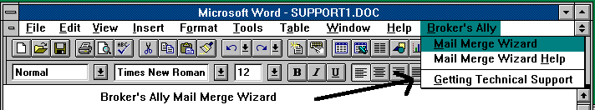
Microsoft Word menu
You may merge all contacts in a Advisor’s Ally data source or merge the contacts in an existing list with a document in Word. You can print letters, labels, or envelopes from Word with your merged information from Advisor’s Ally. For more information, open the User Manual document installed with Advisor’s Ally using MS Word. The file name is userman.doc, and it contains a whole section and even more details on Mail Merge with MS Word and Advisor’s Ally!

5. Backing Up
Q: What files do I back up?
A: The data is in one single file allywin.mdb. To make it easy, just back up all files in the whole directory (\AA1). All Windows versions have a backup facility. You can specify what you want to backup and where you want to save it.
Q: Do I need to back up my data?
A: YES! Your business depends on it. The Rebuild (Maintenance) function can fix the majority of problems that can occur, but it is possible that a database may become damaged beyond repair. When maintenance is not possible, your only recourse is to restore data files from backup diskettes. Always maintain several sets of backup diskettes which are used in rotation; backup diskettes are not immune to failure. There are numerous backup software products available, which are faster and more reliable than the BACKUP and RESTORE programs that accompany Windows, but Windows has it and you can use it anytime.

8. Support Services for Advisor’s Ally
Q: What is the Support Service that I am hearing so much about?
A: The Advisor’s Ally Support Service is designed for your long-term support needs. The popularity of Advisor’s Ally requires full time staff to be made available to your needs. The Support Service provides you with instant access to an Advisor’s Ally support technician and a newsletter with tips and tricks for using Advisor’s Ally to its fullest potential. First, the Support provides you with a toll free 800 support hotline. This hotline will be your instant pipeline to a qualified support engineer every time you pick up the phone. Secondly, you will receive the “The Ally Newsletter” which is a detailed newsletter that is full of tips and techniques on how to make the most efficient use of Advisor’s Ally. It will highlight the powerful (and often overlooked) features of the program.
The Support Service virtually eliminates costly down time due to problems with your Advisor’s Ally Program or your computer system itself. Without the instant access to a qualified support engineer, you may lose a couple of hours of productive prospecting.

9. Market Data Connectivity
Q: How do I update my portfolio prices in Advisor’s Ally?
A: Scherrer Resources, Inc. has developed electronic links to the FT-IDC (Financial Times Interactive Data Corporation) data feed connectivity. This option is provided within Advisor’s Ally under the File, Database Operations, Import Menu. You must contact FT-IDC directly for this data feed subscription. There will be a fee charged by FT-IDC to provide the data you require with the frequency you demand. Categories of data provided by FT-IDC are equities (including mutual funds), ADR evaluations, Options, corporate and government bonds, FNMA, GNMA, and FHLMC pass-through pools, municipal bonds, commodity and futures contracts, collateralized mortgage obligations (CMO) and Asset-backed securities (ABS).
The data feed utilities load data into the data tables of the securities master file of Advisor’s Ally. This data file is a robust file holding several types of data including the security name, type, CUSIP, description, prices including “as of” dates, annual income, maturity date, pricing service that provided the data, corporate action stock split dates and ratio, global change pricing features and many others.

10. Upgrade from Version to Version
Q: How do I upgrade my Advisor’s Ally from version to version?
A: We ship you newest builds when ready for distribution. The installation process will normally detect that you have a previous version and offer you an option to convert all data and files and settings automatically. Then, run your new version software, and you are set to go. If you have problems, contact your Help Desk Technicians- 484-875-1705, Support@AdvisorsAlly.com, Fax Back Assistance- 484-875-1704, Annual Support Contract Subscriptions- 800-950-0190, or Support@AdvisorsAlly.com

1/25/2013


120 Arrandale Boulevard, Exton, PA 19341 484-875-1710 www.AdvisorsAlly.com

